2.2. RACIONALNI BROJEVI I BROJEVNI PRAVAC
24.
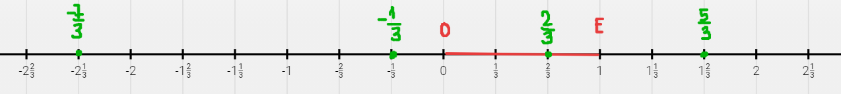

25.
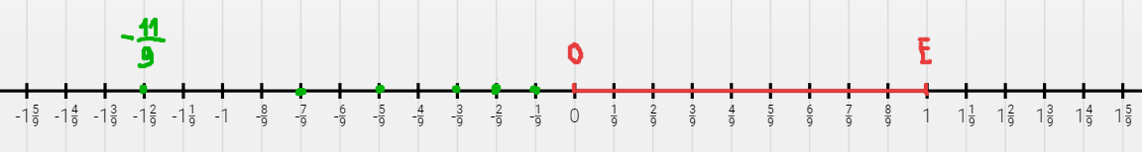
a)

b)
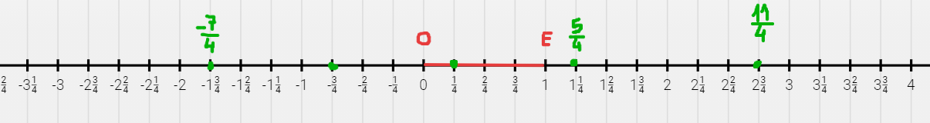

c)

d)

27.
a)
Pogledati ovdje
b)
Pogledati ovdje

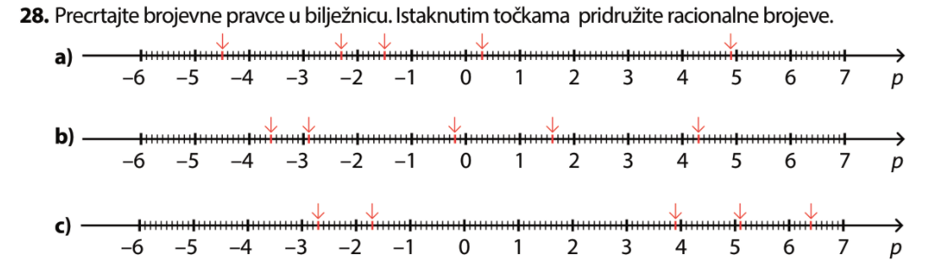

33.
Broj | $$\frac{38}{26}$$ | $$-\frac{9}{17}$$ | $$-\frac{96}{69}$$ | $$\frac{17}{71}$$ | $$2.539$$ | $$4.798$$ | 0$-0.007$ | $$-14\frac{15}{16}$$
Suprotan broj | $$-\frac{38}{26}$$ | $$\frac{9}{17}$$ | $$\frac{96}{69}$$ | $$-\frac{17}{71}$$ | $$-2.539$$ | $$-4.798$$ | $$0.007$$ | $$14\frac{15}{16}$$
Apsolutna vrijednost | $$\frac{38}{26}$$ | $$\frac{9}{17}$$ | $$\frac{96}{69}$$ | $$\frac{17}{71}$$ | $$2.539$$ | $$4.798$$ | 0$0.007$ | $$14\frac{15}{16}$$

34.
Suprotni brojevi su jednako udaljeni od 0, odnosno imaju istu apsolutnu vrijednost.
a) $-1 i 1$
b) $56.56 i-56.56$
c) $-65.65 i 65.65$
d) $\frac{6}{5} i-\frac{6}{5}$
e) $-6\frac{5}{6} i 6\frac{5}{6}$

35.
$$\left|1.5\right|=1.5$$
$$\left|-2\right|=2$$
$$\left|\frac{7}{3}\right|=\frac{7}{3}$$
$$\left|-8\frac{1}{6}\right|=8\frac{1}{6}$$
$$\left|-1.9\right|=1.9$$
$$\left|0\right|=0$$

36.
a) nije točna jer apsolutna vrijednost ne može biti negativna
b) točno
c) točno
d) nije točna jer apsolutna vrijednost ne može biti negativna
e) točno jer je $\left|-0.23\right|=\left|-\frac{23}{100}\right|=\frac{23}{100}$

37.
a)
$\frac{15}{3}=15 :3=5$ suprotan $-5$
$1\frac{3}{4}$ suprotan $-1\frac{3}{4}$
$-0.5=-\frac{5}{10 }=-\frac{1}{2}$ suprotan $\frac{1}{2}$
$\frac{1}{10}$ suprotan $-0.1=-\frac{1}{10}$

b)
$\frac{9}{10}$ suprotan $-0.9=-\frac{9}{10}$
$\frac{12}{4}=12 :4=3$ suprotan $-3$
$\frac{3}{3}=3 :3=1$ suprotan $-1$
$1\frac{1}{4}$ suprotan $\frac{-5}{4}= -1\frac{1}{4}$

DOPUNSKI ZADACI
39.
$\frac{2}{3}$ suprotan je $-\frac{2}{3}$
-1 suprotan je 1
$\frac{1}{5 }$ suprotan je $-\frac{1}{5}$
$-\frac{5}{6}$ suprotan je $\frac{5}{6}$
0.3 suprotan je $-0.3$
$-4\frac{1}{2}$ suprotan je $4\frac{1}{2}$
0 suprotan je sam sebi.

40.
$$\left|\frac{3}{5}\right|=\frac{3}{5}$$
$$\left|-2\right|=2$$
$$\left|\frac{1}{7}\right|=\frac{1}{7}$$
$$\left|-\frac{6}{11}\right|=\frac{6}{11}$$
$$\left|-3.3\right|=3.3$$
$$\left|2\frac{1}{3}\right|=2\frac{1}{3}$$
$$\left|0\right|=0$$

42.
a) x = -9.32, y = 6.5
$$\left|x-y\right|=\left|-9.32-6.5\right|=\left|-15.82\right|=15.82$$
$$\left|x|+|y\right|=\left|-9.32|+|6.5\right|=9.32+6.5=15.82$$
$$\left|x|-|y\right|=\left|-9.32|-|6.5\right|=9.32-6.5=2.82$$
$$\left|x+y\right|=\left|-9.32+6.5\right|=|-2.82|=2.82$$

b)
$$\left|x-y\right|=\left|-7.3-\left(-11.42\right)\right|=\left|-7.3+11.42\right|=\left|4.12\right|=4.12$$
$$\left|x|+|y\right|=\left|-7.3|+|-11.42\right|=7.3+11.42=18.72$$
$$\left|x|-|y\right|=\left|-7.3|-|-11.42\right|=7.3-11.42=-4.12$$
$$\left|x+y\right|=\left|-7.3+(-11.42)\right|=|-18.72|=18.72$$

c)
$$\left|x-y\right|=\left|0.252-\left(-6\right)\right|=\left|0.252+6\right|=\left|6.252\right|=6.252$$
$$\left|x|+|y\right|=\left|0.252|+|-6\right|=0.252+6=6.252$$
$$\left|x|-|y\right|=\left|0.252|-|-6\right|=0.252-6=-5.748$$
$$\left|x+y\right|=\left|0.252+(-6)\right|=|-5.748|=5.748$$

d)
$$\left|x-y\right|=\left|\frac{15}{8}-\frac{7}{8}\right|=\left|\frac{8}{8}\right|=1$$
$$\left|x|+|y\right|=\left|\frac{15}{8} \right|+ \left|\frac{7}{8}\right|=\frac{15}{8}+\frac{7}{8}=\frac{22}{8}= \frac{11}{4}$$
$$\left|x|-|y\right|=\left|\frac{15}{8} \right|- \left|\frac{7}{8}\right|=\frac{15}{8}-\frac{7}{8}=\frac{8}{8}= 1$$
$$\left|x+y\right|=\left|\frac{15}{8}+\frac{7}{8}\right|=\left|\frac{22}{8}\right|= \frac{22}{8}= \frac{11}{4}$$

43.
a) $\left|-6\frac{1}{11}\right|=6\frac{1}{11}> -6$ pozitivan uvijek veći od negativnog
b) $\left|-\frac{28}{9}\right|=\frac{28}{9}$ 28 : 9 = 3 $\frac{28}{9}=3\frac{1}{9}$
1
3 < $3\frac{1}{9}$
c)
$\left|-\frac{27}{5}\right|=\frac{27}{5}$ 27 : 5 = 5.4 $\frac{27}{5}=5.4$
20
0 $\left|-\frac{27}{5}\right|=5.4$

d) $\left|-0.003\right|= 0.003$
$$-1< 0.003$$

44.
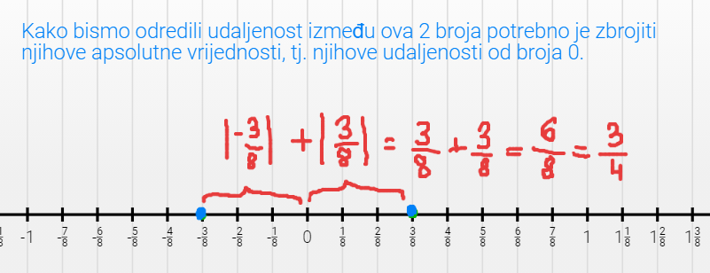
a)

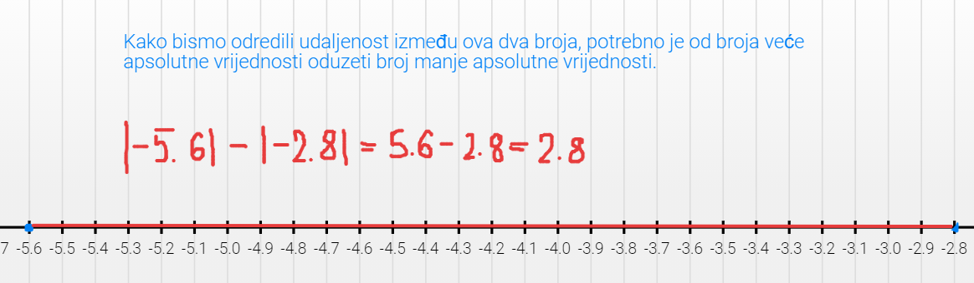
b)

c)
$1\frac{3}{5}= \frac{8}{5}$ $1.6=\frac{16}{10}= \frac{8}{5}$
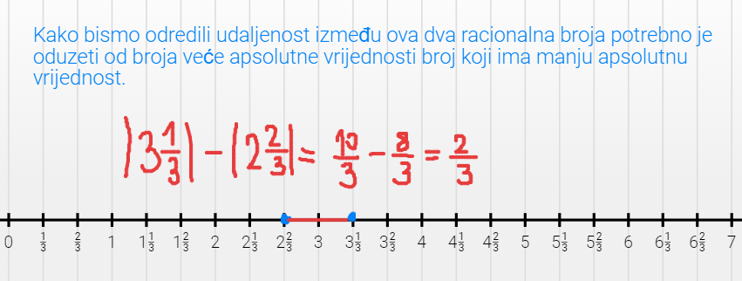
Prvi i drugi broj su jednaki, pa je udaljenost između njih na brojevnom pravcu 0.
d)

